Amara Training
If you see ‘Use Amara to create caption file’ on Basecamp, Don’t Panic.
I’m going to walk you through Amara here.
Amara is the online ‘alternative’ to Caption Maker. It is designed to caption videos from YouTube and Vimeo, and I think it’s relatively simple to use.
So, go to Amara.org, and create a sign on. It’s very simple but then you’ll be set up and can easily look back at projects you have done.
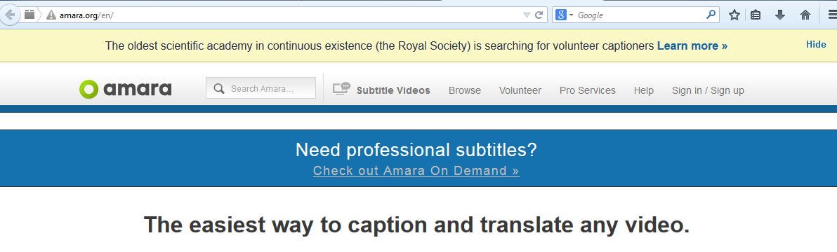
One you have your account set up, copy the link (from Basecamp) into Amara at the ‘Add Video here’ box. Give it a moment to load.
NOTE:
Amara takes YouTube, Vimeo and html5 files
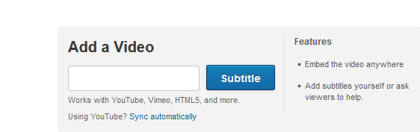

On the left, you will choose ‘Add a language.’ If you’re the first, type ‘En’ to get it to English quickly. There may already be subtitles in Amara for your video. If so, Win! but you will need to check it over, as not everyone captions to our standards.
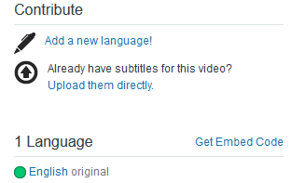
You’ve loaded your video and are ready to caption. Hit tab and the video will start playing, and start captioning. [Enter] will give you additional lines for captioning, as will clicking on the ‘+’ sign in the caption itself. Captions are always inserted below, so plan accordingly. I tend to create a number of blank captions to get started; you can always delete any unneeded captions by clicking on the ‘x’ in the caption itself.
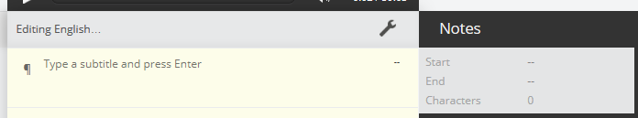
When you have created your captions, you can go on to synching the captions.
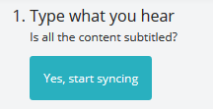
Amara does this by using the down arrow [↓] key to begin a caption, and the up arrow [↑] to end a caption.
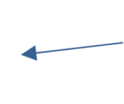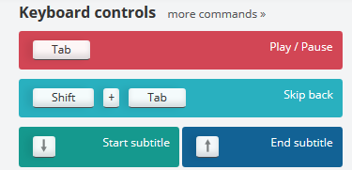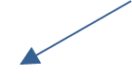
It may take a little while to get used to using both, but fret not, Amara is friendly about letting you change. If I am really having trouble catching it all, I find that going through once, just focusing on the beginnings, and then again just focusing on the endings, can be a more focused approach.
Amara autosaves, so you don’t have to worry about losing data if you step away or forget to save – but if you’re unsure or it would make you feel better on a longer video, there is a save button in the upper left, to make sure.
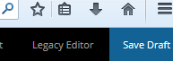
If you walk away and come back, just click on ‘English language’ (unfinished) on the left, then on the upper right, ‘Edit subtitles’ and you’ll be back where you want to be.
Unlike in Caption Maker, in Amara you are going to want to keep the captions to one line, the exception being changing of speakers, when the speaker identification typically goes on the first line, then text on the second. Break captions that wrap or push the boundaries of the video; there isn’t a hard and fast number of characters, but over 40 gets crowded for a caption. Amara will let you know if you’re over 42 characters and recommend breaking captions.
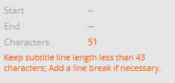
You can navigate the captions in Amara but using the progress bar under video, or by pulling the timeline right or left. Captions can be manually shortened, lengthened or moved as necessary.
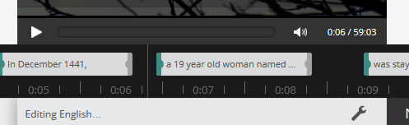
timeline
Progress bar

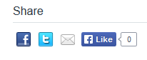
When you are satisfied with the synching, chose complete. It will bring you back to the page for the video. On the lower left, click on the little envelope (e-mail to friends).

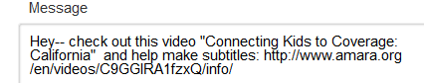
Copy the whole url it brings up back into basecamp by editing the ‘Create caption file.’ [Shift][Enter] to get a second line, if needed, and past the url in there. Save, and don’t forget to enter your time.
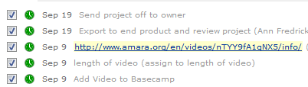
Congratulations, you’re done!

